BPM Application – Provider User Guide

  - January 2019
  - Version 1.01

Best Practice Management, LLC
7904 E Chaparral Rd A110-296
Scottsdale, AZ 85250-7210
WEB PAGE: http://bestpractice-llc.com/
BPM APP: https://bestpractice.us/app/user/login
1.800.717.4215

All Rights Reserved © 2019

Document Revisions

Date | Version Number | Document Changes
01/23/2019 | 1.00 | Original Document
02/14/2019 | 1.01 | Appointment fee updates

Table of Contents
1 Introduction 5
1.1 Scope and Purpose 5
1.2 Overview 5
2 WorkFlow 6
2.1 Getting ready – What you will need 6
2.2 How to Log into BPM’s Alpha 7
2.3 How to Configure your Provider Settings 7
3 PATIENT PROCESSES 12
3.1 How to Add A New Patient 12
3.2 How to Create an Appointment 13
3.3 Print a daily or weekly worksheet 15
3.4 Completing the appointment 16
3.5 Completing the appointment for a GROUP 17
3.6 Print a Receipt 18
4 OFFICE PROCESSES 19
4.1 Using Notes 19
4.2 Print a Patient Invoice 21
4.3 Print a Demo Form 22
4.4 How to lookup a patient’s upcoming appointments 23
4.5 How to look up a patient’s previous appointments (DOS) 23
4.6 Private Pay Patients (FFS) 23
4.7 Patient Email Appointment Reminders 24
5 Appendices 25
6 Index 26

Introduction

Scope and Purpose
This manual is an introduction to the Best Practice Management’s Alpha online mental health provider application.

Alpha is designed for ease of use and includes the tools, forms, and information to simplify the most common office requirements in an intuitive and easy to learn application.

Overview
With BPM’s Alpha you will be able to:
- Add new patients
- Schedule appointments in a scheduling calendar
- Print your weekly or daily schedule including patient responsibility and patient balance.
- Print patient invoices
- Print patient intake forms
- Automatically email reminders to patients
- Add patient notes
- Review patient responsibility, insurance and patient balances

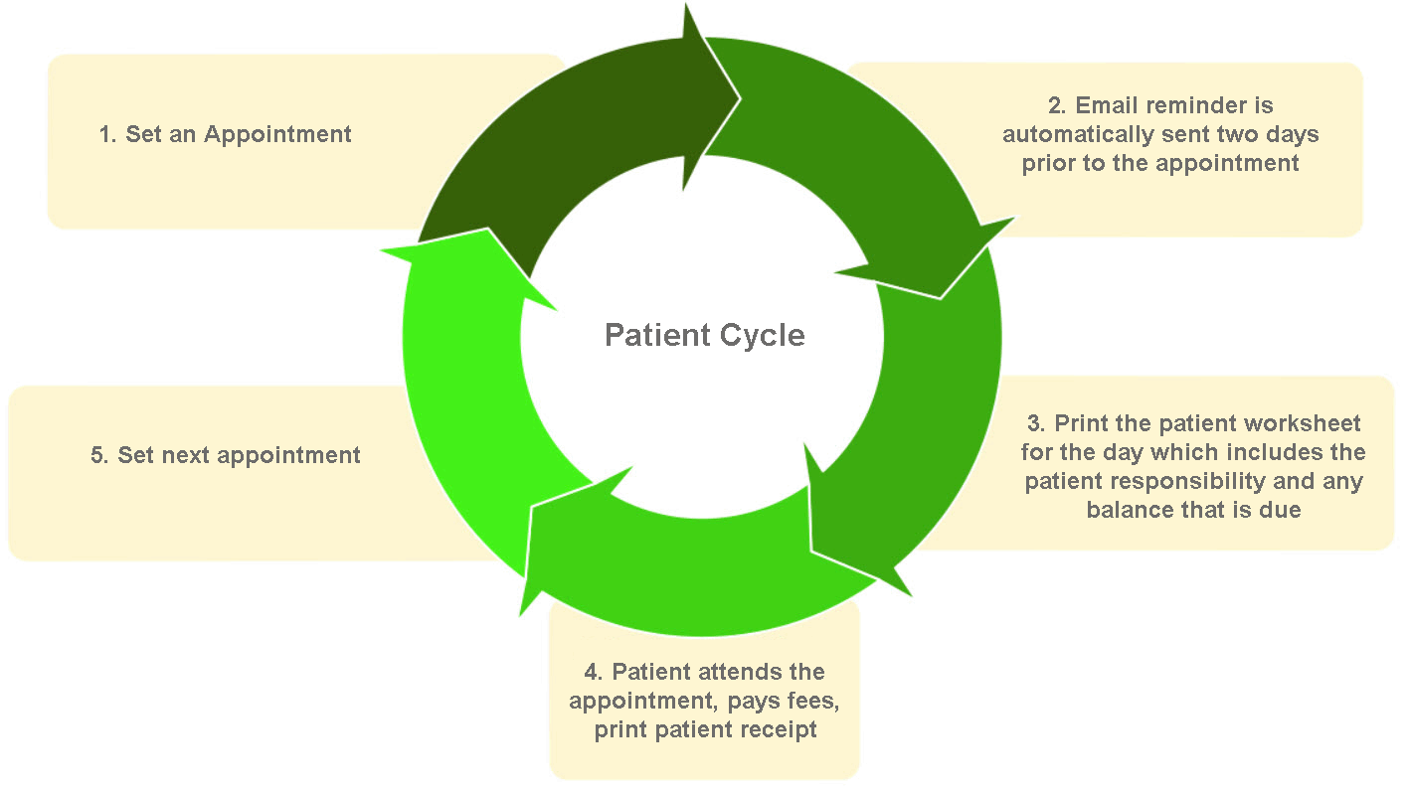

Work Flow
After logging into BPM’s Alpha, you will be presented with your provider’s “dashboard” page. This is the starting place for everything you will want to do in Alpha.
From the dashboard you may:
- View your appointments by month, week or day
- Open an already scheduled appointment
- Create a new patient appointment.
- View the days and or hours that you are available/unavailable
- Print a worksheet for “today”, the “Week” or the “Month”.
- Add an Appointment
- Search for a patient record
- Look at a patient list.
- Go to your provider settings page
- Open a “note”
- Logout

Getting ready – What you will need
Before you can use BPM’s Alpha, you must configure your provider settings
You will need:
- The providers name (as it is written on your license)
- (The email address is the one used to set up your account) Changing the email address will require you revalidate your email address and password.)
- Phone numbers (Home, mobile, work and fax)
- Date of birth
- Your professional license number and the issue date
- Your social security numbers
- Your EIN tax number
- NPIs (Individual and group NPI if you have one)
- Railroad Medicare ID and PTAN if you have one
- Medicare PTAN if you are a Medicare provider
- Specialty (short description)
- Your Taxonomy code
- Billing address
- Service location address(es)

How to Log into BPM’s Alpha
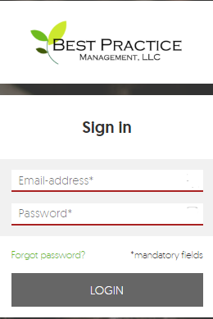
- Go to URL https://bestpractice.us/app/user/login
- Enter your email address and the password.
If you forget your password, click on the “Forgot password” link. An email will be sent to your email address. Follow the instructions in the email to reset your password.

How to Configure your Provider Settings
- Once you are logged into Alpha you will be presented with your provider dashboard page.
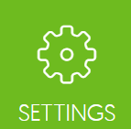
- In the upper right-hand corner of the screen is a green “Settings” button. Click on it.
- You will now be presented with an “Account Settings” page.
- On the left-hand side of the page is “Personal Information” Enter the providers personal information here.
- First, Middle and Last name: Enter your name exactly as it appears on your professional license.
- Title: Enter your credentials.
- Email address is already entered. If you change the email address, you will be required to validate the email address and update the password. This is a part of the user security protocols.
- Enter your phone numbers. The “work” phone permits an extension to be added.
- Fax: Enter your fax number.
- Date of Birth: Enter your date of birth. xx/xx/xxxx
- License Number: Enter your professional license number.
- License Date issued: The date your license was issued.
- SSN: Your social security number.
- EIN: If you have an Employer Identification Number (EIN) enter it here.
- Individual NPI: Enter your individual (Type 1) National Provider ID (NPI).
- Group NPI: If you have a group NPI (Type 2) enter it here
- RR Medicare ID: If you are a Railroad Medicare Provider enter your ID here.
- RR Medicare PTAN: Enter your Railroad Medicare Provider Transaction Access Number (PTAN) here.
- Medicare PTAN: If you are a Medicare Provider, enter your Medicare Provider Transaction Access Number (PTAN) here.
- CAQH ID: Enter your Council for Affordable Quality Healthcare ID (CAQH)
- Specialty: Enter a short specialty description. (Social Worker Clinical)
- Specialty taxonomy: Enter the taxonomy code used when applying for insurance panels.
- Click “Save”
- At the top of the page (center) is your address information. There are two addresses that must be entered. Add your addresses.
  - Billing Address:
- The billing address is the location where you want checks from insurance payers to be mailed. It may be the same address as your Service location address.
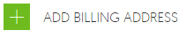
- Click on “ADD BILLING ADDRESSES” The ADD BILLING ADDRESSES Popup will open.
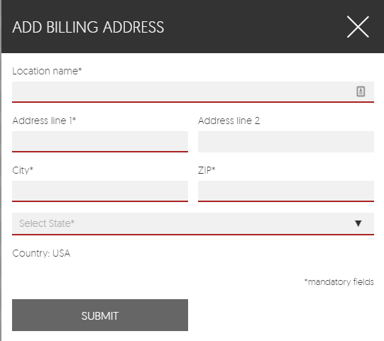
- Location name: Enter the provider name or the Corporation name if incorporated. (This is the name that will appear on mail correspondence)
- Address: Enter the address where you want correspondence and insurance payments to be made
- Click Submit.

- Service Location Address.
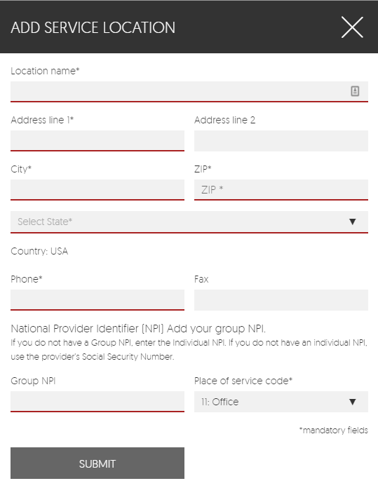
  - The Service Location address may be the same address as the Billing Address. It is the location where services are rendered. Add as many service locations as needed.
  - Click on “Add Service Location”. An ADD SERVICE LOCATION popup will open.
  - Add the Service location name. If you are incorporated add the corporation name. (This is name that will appear on mail correspondence)
  - Add an office phone number.
  - Add a fax number.
  - Add your NPI. IF you have a group NPI enter it here. If you do not have a group NPI but have an individual NPI enter it, instead. If you do not have an NPI enter the providers SSN.
  - Place of service code: Enter the appropriate code for the service location. An office location is 11, Hospital is 21, etc.
  - Click Submit.
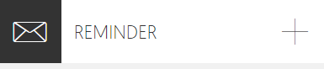
- REMINDER: On the upper right-hand side of the page are the email reminder settings. Click on the plus (+) sign to open.
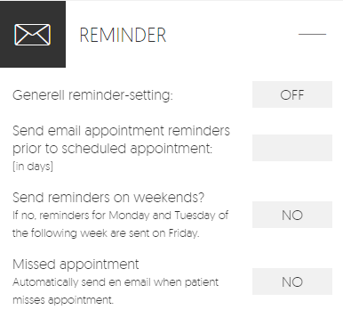
- To turn on email reminders click on “OFF” and it will turn green and indicate “ON”.
NOTE: Email reminders must be enabled in a patient record for a patient to receive an email reminder.
- Send email appointment reminders prior to the scheduled appointment: Insert the number of days prior to the appointment. (We recommend 2 days)
- Send reminders on weekends? Yes, or no.
- Missed appointment. Enable if you would like the patient to receive an email advising them that they missed their appointment and will need to reschedule. Email must first be enabled in the patient record.
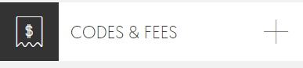
- CODES & FEES On the upper right-hand corner of the Account Settings page is the CODES & FEES tool. This where you will enter your fee schedule for your practice. Click on the plus (+) sign to open.
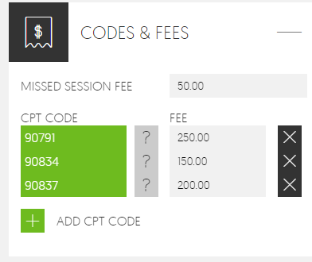
- MISSED SESSION FEE: Enter the amount you charge for late cancellations and missed appointments.
- CPT CODE: To add a CPT code click on the green plus sign “Add CPT CODE”. A field will open. Type either the CPT code or a key word. Click on the option in the dropdown list to add the CPT Code to the list.
- Hover over the gray question mark to view the short description
- Add a fee. (See the example for CPT code 90791. The fee associated with this CPT code is $250.
- To remove a CPT code and its fee click on the “X” to the right.

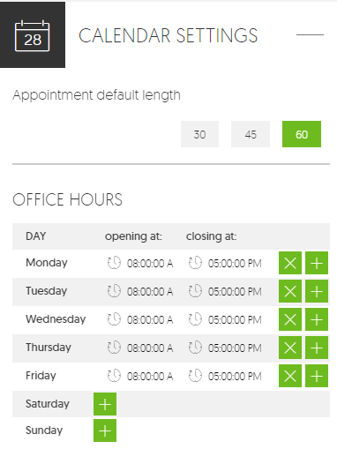
- CALENDAR SETTINGS: Use the CALENDAR SETTINGS tool in the upper right-hand corner of the ACCOUNT SETTINGS page to customize your Dashboard calendar.
a. APPOINTMENT DEFAULT LENGTH; Set the default appointment length to either 30, 45 or 60 minutes.
b. OFFICE HOURS: Set your office hours to display the available times in your appointment calendar on the dashboard. Add additional lines to denote lunch, unavailable, etc.
NOTE: Available hours have a white background. Unavailable times (those in gray) may still be used to create appointments.
- To set office hours click enter a beginning and end time for the day of the week. Delete an entry by clicking on the green “X” Days with no entries are assumed to be “Unavailable”.
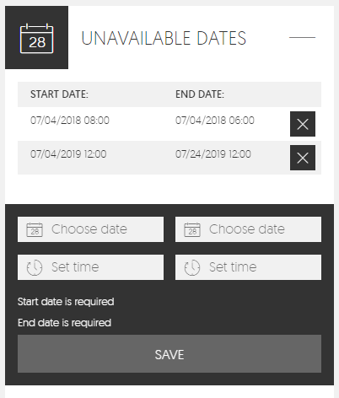
- UNAVAILABLE DATES: You can “block out” dates and times with the UNAVAILBLE DATES tool. Click on the plus (+) sign to open.
  - To block out a date click on the plus (+) sign next to the green “ADD DATE”
- You must assign a starting date and an ending date. Add times as needed. Click “SAVE”. The date/time selected will be gray on the appointment calendar.
- To delete an unavailable date click on the “X” to the right.

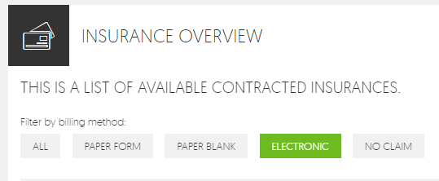
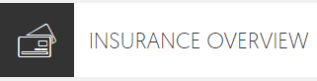
- INSURANCE OVERVIEW: The INSURANCE OVERVIEW is a listing of the provider’s insurance payers. Locate the Insurance overview at the bottom of the ACCOUNT SETTINGS page and click on the plus (+) sign to open.
  - The insurance payers may be sorted by billing method. (how the claims are submitted for payment).
- ALL: All available insurance payers are displayed.
- PAPER FORM: Claims that must be submitted to the payer with a paper insurance claim form.
- ELECTRONIC: Claims that are submitted electronically to a clearing house. (These nearly always require a “Payer ID” A Payer ID is usually a 5-character ID that is alphanumeric and used to identify which insurance payer should receive the claim.)
- NO CLAIM: NO CLAIM is nearly always used for EAP or other special contracts that use a proprietary claim form.
- Search for an available insurance payer by name or payer ID. Enter the insurance name or payer ID to search for an insurance.
- The available list of providers indicates whether the provider in “in-network” , the name of the insurance provider, Payer ID (if there is one), Address, Contact phone number and the billing method.
- You may further sort insurance payers by clicking on the field:
- IN NETWORK: The insurance payers are further sorted by those who are “In Network” (the provider is contracted with the insurance payer).
- NAME: Sort the list by insurance payer name.
- Payer ID: Sort the list by Payer ID.

PATIENT PROCESSES

How to Add A New Patient

- Log into BPM’s Alpha. You will be redirected to the Dashboard.
- Begin by searching for the patient to ensure that no patient record exists.
- If no record is found, Click on the blue “INTAKE FORM” button. The INTAKE FORM – Add new patient page will open. Only three fields are mandatory. (This enables the user to schedule an appointment with virtually no patient information.) The patient’s first and last name and a mobile phone number are required to save the intake form.
- Begin in the upper left-hand corner with CREATE NEW PATIENT.
  - Enter the patient’s First, last middle and nick name.
  - Gender: There are two options; male and female. For other genders or when gender is unknown, leave the gender field blank.
  - Marital status: Select either married, not married, other or leave the field blank.
  - Date of birth: enter the patient’s date of birth
  - SSN: With the exception of military insurance there is no advantage to storing the patient’s social security number.
- CONTACT INFORMATION:
- Enter the mailing address, email address and phone numbers for the patient.
- Preferred method of contact: This indicates the patient’s preferred method when they must be contacted. Select one of five methods of contact. Mobile phone, Home phone, Work phone, Text or by Email.
- ADDITIONAL INFORMATION:
- Enter the name and phone number of the Primary Care Physician (PCP)
- Referred by? Enter the name of the person or office who referred the patient. This information is useful for marketing and other purposes.
- EMERGENCY CONTACT:
- Enter the name of the person to call in an emergency.
- Relationship to the patient: This can be a spouse, friend… anyone.
- Enter a home and mobile phone for the emergency contact.
- MEDICAL INFORMATION: (These are note fields)
- Medications being taken:
- Current Medical conditions
- Special instructions:
- FFS Fee: “Fee for Service” (FFS) means that the patient pays out-of-pocket. The fee for the appointment may be recorded here.
- Click “SAVE” Missing or Improperly formatted information will have to corrected before you can save the intake form.
- Click “CLOSE” and you will be returned to the Dashboard.

How to Create an Appointment

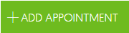
- From the Dashboard, click on the “+ ADD APPOINTMENT” button located in the center-top of the Dashboard page. The “Create NEW APPOINTMENT” tool will open to the right of the calendar.
- There are two (2) methods to add an appointment date/time:
- Add date/time by calendar
- Add date/time from the “Create New APPOINTMENT” tool.
- Add a date from the calendar.
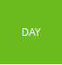
- The default view for the calendar is the “Month” view. Change to the “DAY” view by clicking on the “DAY” button near the top of the calendar. The calendar now displays the DAY view.
- Click on an available time. The date and the time for the appointment have been automatically entered into the “SELECTED DATE AND STARTING TIME” AND a black box with “NEW appointment” is in the selected hour.
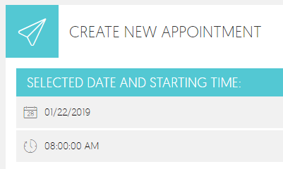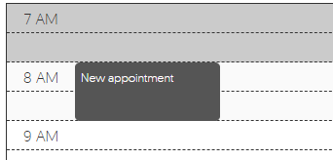
- The default appointment length is a setting in the Provider Settings. It may be adjusted globally to 30, 45 or 60 minutes. In the example the appointment is one hour in length.
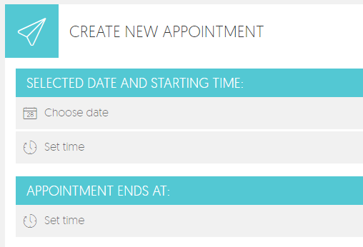
- Add a date/time from the CREATE NEW APPOINTMENT” tool
- Type in the date and time for the appointment.
- Change the length of the appointment, if needed.
- A black “New Appointment” box will be added to the calendar to indicate the appointment. Black is the color for a new appointment.

- Is the appointment a Group, Single or Couple appointment?
- For a Single patient or Couple, place a checkmark in the “Is single Appointment” box.
- To start over click Cancel or click the blue “CREATE APPOINTMENT” box to set the appointment date/time and type of appointment.
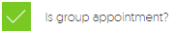
- For a Group appointment, place a checkmark in the “Is Group Appointment?” box. A group appointment is two (2) or more patients who have different insurance payers.
      - Add 2 or more patients to the group session by clicking on the “ADD PATIENT” button.
- To start over click Cancel or click the blue “CREATE APPOINTMENT” box to set the appointment date/time and type of appointment.
- Add a patient to the appointment.
- Type a patient’s name to the right of the “ADD PATIENT” box. Select the name from the list that appears. If no name appears use the blue “Intake Form” form to the right to add a new patient.
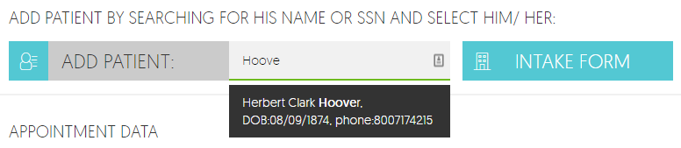
- To remove the patient, click on the “X”.
- To go to the selected Patient Record, click on the blue Profile button.
- You may view the patient’s contact, insurance status and balance information by clicking on the Plus Sign (+). This is not a required step for creating an appointment.
- Choose a service location.
- Place a check mark in the service location box. If there is more than one service location, select the appropriate location for the appointment.
- Add a note. You may add a note that is viewable in both the patient record and on the Dashboard. Click on the green “ADD NOTE” field.
- When the note is completed, click “SAVE NOTE” The saved note is now viewable in the appointment. With a date and time stamp. (Notes cannot be edited or deleted.)
- Save the appointment. Click “Cancel to remove the data from the appointment or click the blue “SAVE APPOINTMENT” box to save the appointment.
- Note that the appointment (in the calendar and at the top of the page) has changed color from black to orange indicating a “Pending Appointment”
- Click the black “X” in the upper right-hand corner to return to the Dashboard view.

Print a daily or weekly worksheet
- It is recommended that you print a list of scheduled appointments daily. Insurance status, patient balances and appointments change frequently.
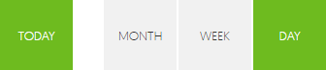
- From the Dashboard, choose, “TODAY”, “WEEK” or “DAY”. The report will list the appointments according to the selection. For instance, “TODAY” will provide a list of your appointments for today.
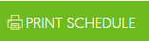
- Click the green “PRINT SCHEDULE” button. Depending on your browser settings, a list will open in a new tab.
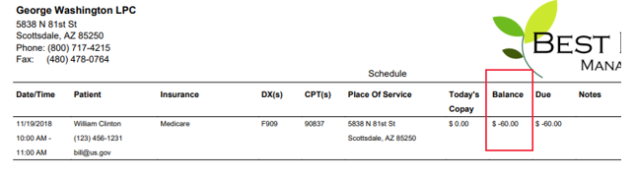
- Print the schedule.

Completing the appointment
- Once you have seen the patient, you are now ready to complete the appointment. From the Dashboard, click on “Today” at the top of the calendar. Your appointments for the day are visible on the calendar.
- Click on the patient’s name in the calendar. The patient’s appointment information will open to the right of the calendar.
- Click on the plus sign (+) to the right of the patient’s name to open the patient’s information.
- Did the patient attend the appointment? Place a check next to one of the three choices; “PATIENT ATTENDED APPOINTMENT”, “PATIENT MISSED APPOINTMENT”, or PATIENT CANCELLED APPOINTMENT”.
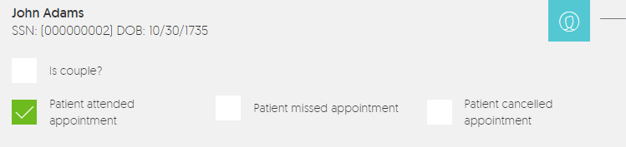
- Patient attended appointment: The appoint was successfully completed
- Patient missed appointment: The patient was not available for the appointment
- Patient cancelled appointment: The patient successfully cancelled the appointment and there is no fee.
- INSURANCE INFORMATION - This does not require any action on the part of the provider and is only information regarding the nature and status of the insurance.
- Insurance information:
      - What is the primary insurance?
      - What method is used to file the claims?
      - What is the insurance status?
- ADD CPT Codes for the appointment. Under the APPOINTMENT INFORMATION FOR THIS PATIENT, begin typing the first CPT code. A List of possible CPT codes and their short description will appear. Click on the CPT code you want.
- CPT Codes and DX codes are “sticky” If you schedule another appointment for this patient, the CPT codes and DX codes will automatically populate in the correct fields.
- Hover the cursor over the gray Question mark (?) next to the CPT code to read the short description.
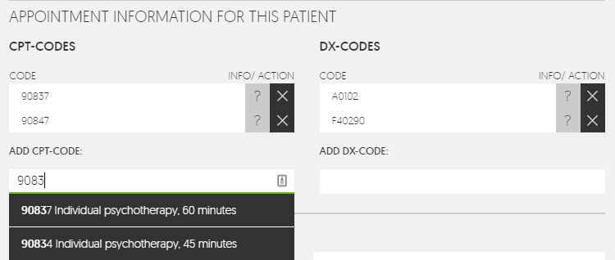
- ADD DX Codes for the appointment. Under “ADD DX_CODE” begin typing the desired DX code. A List of DX codes and their short description will appear. Select the DX code that you require.
- Hover the cursor over the gray Question mark (?) next to the CPT code to read the short description.
- Add patient payment.
- The “Appointment Fee” amount is the insurance patient responsibility and is equal to the “appointment Fee” found in the “Insurance Plans” in the Patient Record.
Note: The “Appointment Fee” may be edited. The edited appointment fee amount is “sticky”. That is, it will carry over to future appointments in the Appointment Fee.
- Make sure that the service location is checked.
- Add a note if needed. You can read previous notes from this field.
- Save the Appointment. Click on the blue “SAVE APPOINTMENT” button.
- Select the next patient appointment and repeat the previous steps or click the black “X” in the upper right-hand corner to return to the Dashboard view.

Completing the appointment for a GROUP
- Once you have Group session, you are now ready to complete the appointment. From the Dashboard, click on “Today” at the top of the calendar. Your appointments for the day are visible on the calendar.
- Click on the first patient’s name in the calendar. A list of patients will open to the right of the calendar.
- Completing the appointment for a group session is nearly the same as for an individual or couple. Under, “PATIENTS” there will be 2 or more patients listed. 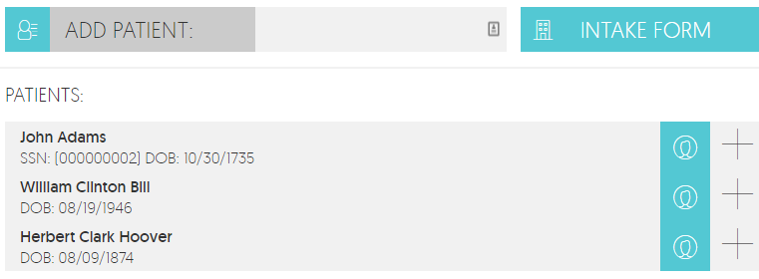Open each patient, one at a time, by clicking on the plus sign (+) and complete the appointment as you would for an individual appointment.
- Complete all the patients and then save the appointment.

Print a Receipt
A patient may request a receipt for a payment made at the time of the appointment. NOTE: A patient payment must be recorded before the “Print RECEIPT” box is available.
- If you have not already done so, save the patient appointment by clicking on the blue “SAVE APPOINTMENT” box at the bottom of the Appointment screen.
- Click the green “Print RECEIPT” button. 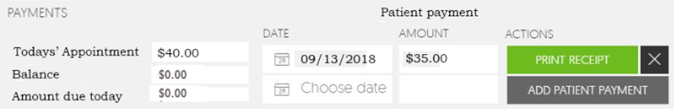
- A printable receipt will open in a new tab.
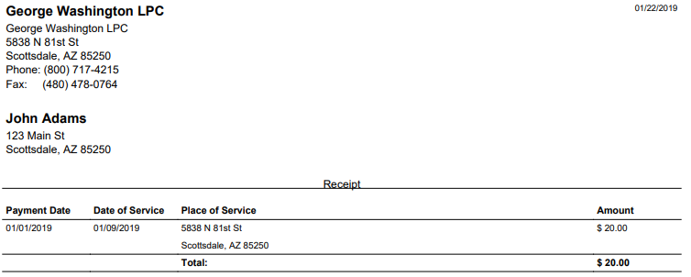

OFFICE PROCESSES

Using Notes
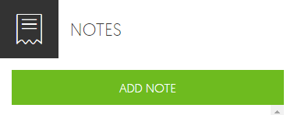
- Notes may be written in three (3) locations; the Dashboard, a Patient Appointment and a Patient Record.
- The most recent notes are viewable from the Dashboard.
- Clicking on a note in the dashboard will return you to the location where it was created. For instance, a note on the dashboard that was created in a patient appointment will open the patient appointment. Likewise, a note created in a Patient Record will open the Patient record where the note was written.
- Once a note is saved it cannot be edited or deleted.

- Creating a Note from the Dashboard.
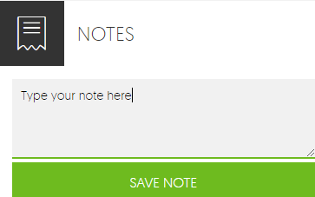
  - The “Notes” are in the center-top of the dashboard page.
  - To create a note from the dashboard, click the green “ADD NOTE” button.
  - Type the note and click the “SAVE NOTE” button.
  - The note will appear on the dashboard notes ONLY.
  - The note will include the author, a date/time stamp and the message.
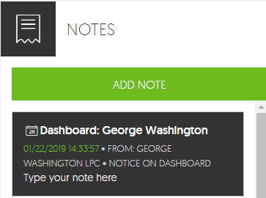

- Creating a Note from the Patient Appointment. Notes may be added to the patient appointment at any time and are viewable in the appointment record and the dashboard.
  - Open a patient appointment. There are three methods to open a Patient Appointment. 1) From the calendar on the dashboard, 2) from a Note on the dashboard, 3) From the Patient Record (DOS) (See: 3.7 How to look up a patient appointment)
  - Click on the green “Add Note” field at the bottom of the “EDIT APPOINTMENT” page.
  - Type a message and click the gray “SAVE NOTE” box.
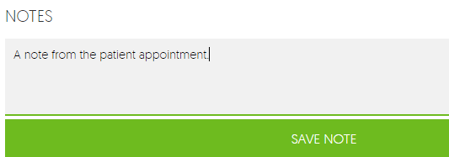
  - The note is saved in both the appointment record and the dashboard notes.
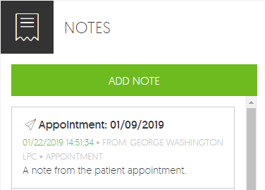
In the patient appointment: 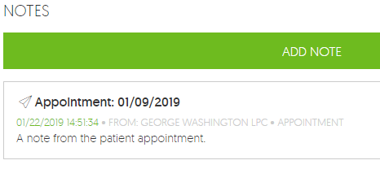
On the Dashboard Notes:

- Creating a note from the Patient Record.
  - Open a patient record. A patient record may be opened using three (3) methods. 1) doing a patient search from the dashboard, 2) from a note on the dashboard, 3) from an appointment,
  - The notes field is in the upper right-hand corner of the Patient record. Click on the plus (+) to view all notes for this patient or to create a new note.
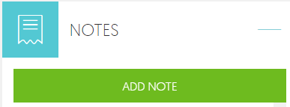
  - Click on the green “ADD NOTE” button to write a new note.

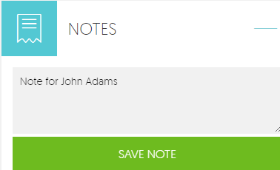
  - Type a note and click the gray “SAVE NOTE” button. The note is now saved in the Patient Record and on the Dashboard Notes.

Print a Patient Invoice
A Patient invoice is a request for payment from a patient. An invoice is not a SUPERBILL, nor is it a Receipt. (See: 2.4.5 Print a Receipt)
- Open a patient record. A patient record may be opened using three (3) methods. 1) doing a patient search from the dashboard, 2) from a note on the dashboard, 3) from an appointment,
- Click on the plus sign on the blue “PATIENT BALANCE” button, located on the right side of the Patient Record. The Patient Balance opens.
- Click on the green “PRINT INVOICE” button. An invoice will open in a new tab.
- Print the Invoice on your local printer.
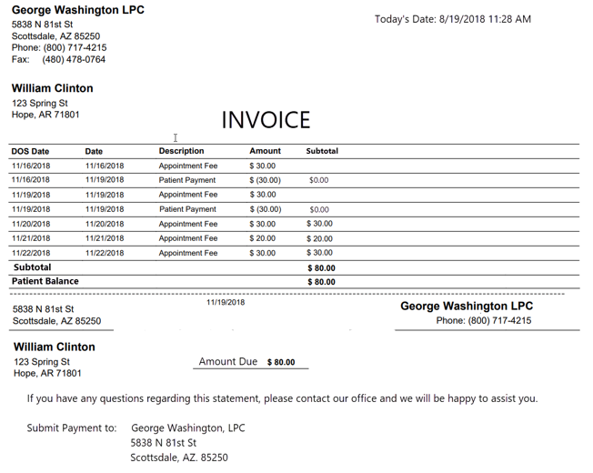

Print a Demo Form
A Demo Form (Demographics Form) may be printed from two (2) locations. 1) the Intake Form and 2) the Patient Record.
- Printing the DEMO Form from the Intake Form.
- While completing a new patient Intake Form, click on the green “PRINT DEMO FORM” button located under the gray bar titled, “DEMO FORM/REMINDER
- A patient Demo Form will open in a new tab.
- Print the Demo Form.
- Printing a DEMO Form from the patient Record.
- Open a patient record. A patient record may be opened using three (3) methods. 1) doing a patient search from the dashboard, 2) from a note on the dashboard, 3) from an appointment,
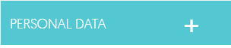
- Click on the plus (+) on the blue “PERSONAL DATA” block. The patient’s personal data opens.
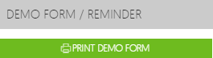
- Click on the green PRINT DEMO FORM” button. A patient DEMO Form will open in a new tab.
- Print the Demo Form.

How to lookup a patient’s upcoming appointments
- Open a patient record. A patient record may be opened using three (3) methods. 1) doing a patient search from the dashboard, 2) from a note on the dashboard, 3) from an appointment,
- Open the blue “FUTURE APPOINTMENTS” block by Clicking on the plus (+). The patient’s future appointments are listed.
- The patient’s future appointments are listed by date, location and status.
- Click on the plus (+) sign to view the appointment.
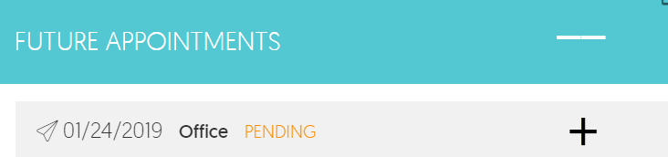

How to look up a patient’s previous appointments (DOS)
- Open a patient record. A patient record may be opened using three (3) methods. 1) doing a patient search from the dashboard, 2) from a note on the dashboard, 3) from an appointment,
- Open the blue “DOS” block by Clicking on the plus (+). The patient’s past appointments are listed.
- The patient’s past appointments are listed by date, location and status.
- Click on the plus (+) sign to view the appointment.
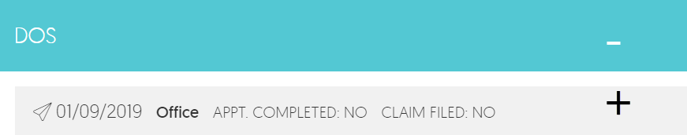

Private Pay Patients (FFS)
Private pay patients (those who pay out-of-pocket) are managed differently than patient’s who have an insurance plan.
- Do not enter insurance information for the patient in the Intake Form or in the Patient Record.
- On the “EDIT APPOINTMENT” page, (the patient appointment), the patient is identified as FFS (Fee For Service). If there is no insurance payer on record for the patient, the green FFS box is automatically checked.
- You may add insurance by clicking on the green “GO TO INSURANCE OLANS” box.
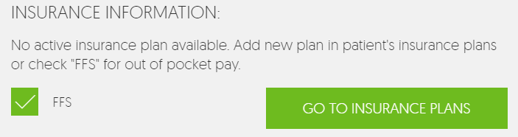

Patient Email Appointment Reminders
Email appointment reminders must first be activated in the ACCOUNT SETTINGS and then activated in the patient record.
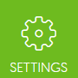
- Configure email appointment reminders in the provider settings.
- From the dashboard, click on the green “SETTINGS” button in the upper right- hand corner of the page. The ACCOUNT SETTINGS page will open.
- Click on the plus (+) on the “REMINDER” block.

There are four (4 ) options:

- “General reminder setting”: Turn Reminders on or off.
- “Send email Appointment reminders prior to scheduled appointment” Type the number of days, prior to the scheduled appointment, the email reminders should be sent. (We recommend two days.)
- “Send reminders on weekends?” Yes or no, should email be sent over the weekend? For instance, should email be sent on Sunday for a Tuesday appointment? If no is chosen, email for Monday or Tuesday will be sent on Friday.
- “Missed Appointment” Yes or no, should an email be sent for a missed appointment?
- Configure email appointment reminders to be sent for a patient.
- Open a patient record. A patient record may be opened using three (3) methods. 1) doing a patient search from the dashboard, 2) from a note on the dashboard, 3) from an appointment,
- Scroll down to the “DEMO FORM/REMINDER bar.
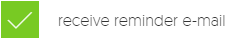
- Click on the green “receive reminder email”.
- Click SAVE.

